Project Title: Real-Time River Water Quality Monitoring and Control System Project Design Phase-I - Solution Fit Template Team ID: PNT2022TMID36352

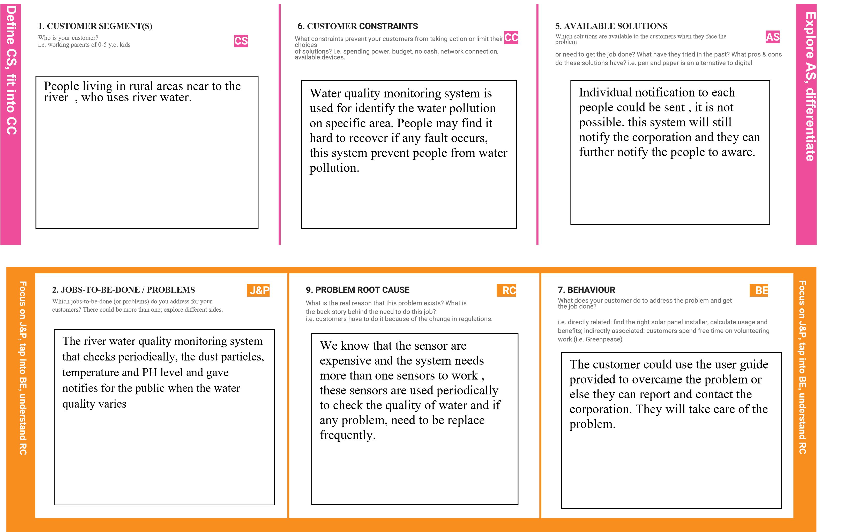

|  |  |  |  |  |  |  |  |  |  |  |
| --- | --- | --- | --- | --- | --- | --- | --- | --- | --- | --- |
|  |  | |  |  | |  |  | | |  |
| 3. TRIGGERS | TR | 10. YOUR SOLUTION | SL | 8. CHANNELS of BEHAVIOUR | CH |  |
| What triggers customers to act? i.e. seeing their neighbour installing | |  | If you are working on an existing business, write down your current solution first, fill | |  | 8.1 ONLINE | | |
| solar panels, reading about a more efficient solution in the news.   |  | | --- | | River water quality analysis work by Checking the river water quality for providing clean drinking water for the people, farming, promoting aquaculture, and other industries. It is the best replacement for checking water quality in laboratories. The best quality is that it is user-friendly. | | |  | in the canvas, and check how much it fits reality.  If you are working on a new business proposition, then keep it blank until you fill in the canvas and come up with a solution that fits within customer limitations, solves a problem and matches customer behaviour.       |  | | --- | | This technology can automatically monitor the water quality. The water detection sensor has a unique advantage. It consumes less time than a manual method for checking polluted levels. Information is sent at in faster rate to authorities and action can be taken immediately affected rate  of pollution is reduced | | |  | What kind of actions do customers take online? Extract online channels from #7    8.2 OFFLINE  What kind of actions do customers take offline? Extract offline channels from #7 and use them for customer development.   |  | | --- | | ONLINE:   * Public may provide review and rating for the system. * The software used should be properly studied by everyone to operate it. * The software and hardware connections should be given properly | | | |
|  | |  |
| 4. EMOTIONS: BEFORE / AFTER | EM |
| How do customers feel when they face a problem or a job and afterwards? | |  |
| i.e. lost, insecure > confident, in control - use it in your communication strategy & design.     |  | | --- | | BEFORE:   * Before implementing this project people feel it was difficult to enjoy boating, fishing, and provision safe drinking. * They also face major problems in the development of industrial, hydroelectric, and agricultural water requirements.   AFTER:   * After implementing this project people can be able to face all these above-mentioned problems easily. | | |  |